**React Fundamentals**

1. **Component**
2. **Props => Properties**
3. **State**

**Todays Subjects**

Style to Component

Bracket{}

Props => Properties

Conditional rendering

**Starting React Project**

npm install -g create-react-app

npx create-react-app PROJECT-NAME

cd PROJECT-NAME

npm start

**Notes:**  
  
Class Componen arxada bir function yaradir. JS functional programming language oldugu ucun base inde (fundamentalinda) funksiyalar durur.

Styling:  
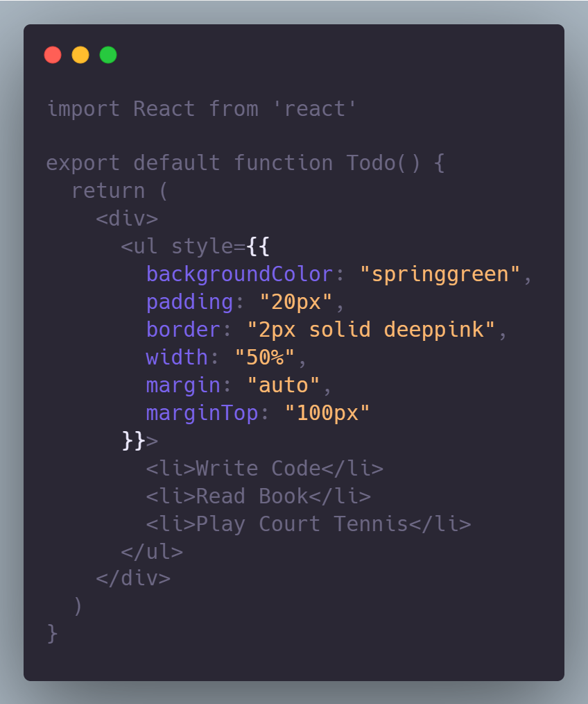

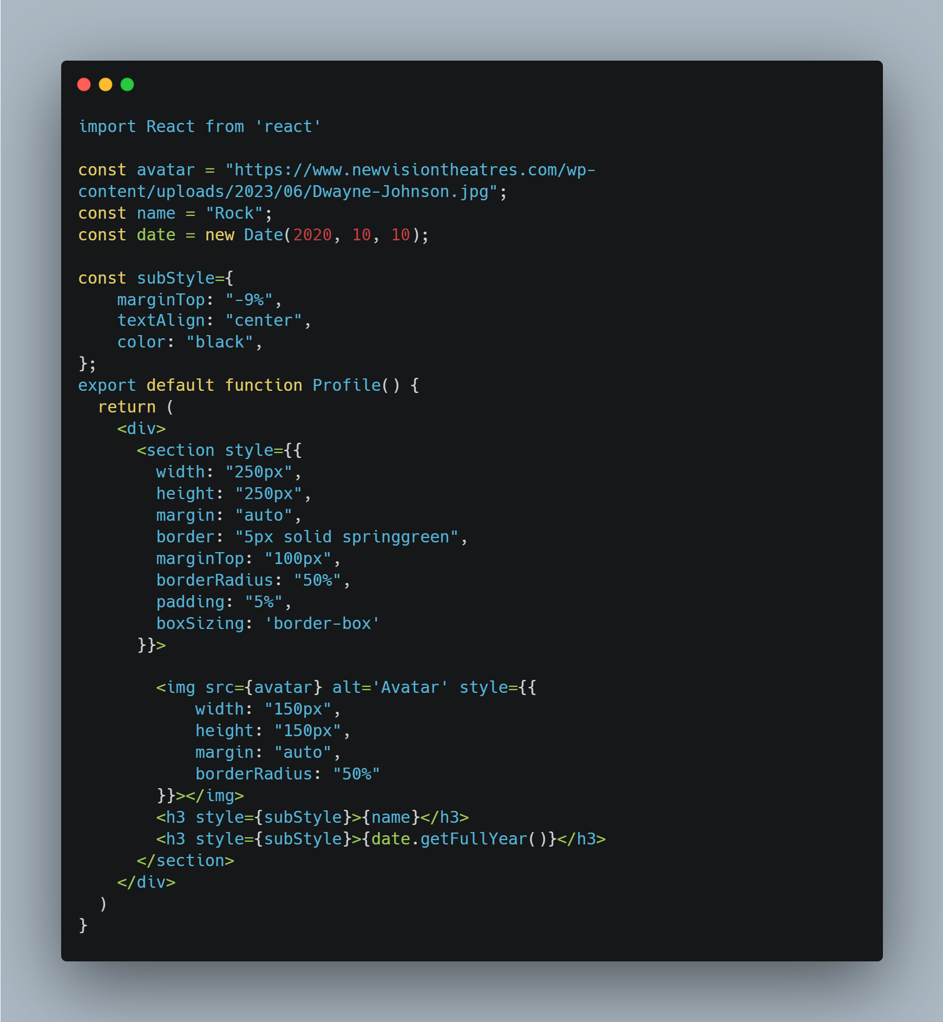

USING BRACKETS:   
import React from "react";

const person = {

name: "Ayxan",

age: 24,

theme: {

backgroundColor: "deepskyblue",

color: "white"

}

}

function getFullInfo(){

return "NAME : " + person.name + " AGE :" + person.age;

}

export default function Item() {

return (

<div>

<h1 style={person.theme}>My name is {person.name}</h1>

<h2>I am {person.age} years old</h2>

<span>{getFullInfo()}</span>

</div>

);

}

PROPS:

Bir componented sub componentde data gonderkmek ucun vasitedir.

Parent componentden child componente data gonderdikde child componentde datani this.props vasitesile aliriq. Deyek ki, User Componenti var var parentde yaziriq. <User></User>.

Data gondermek ucun :   
<User myinfo=”Ayxan”></User> yaziriq.

myinfo propertiye ozumuzun verdiyi addir. Child componende ise this.props.myinfo vasitesi ile “Ayxan” datasini ala bilerik.